* Power MOSFET – IRFP260

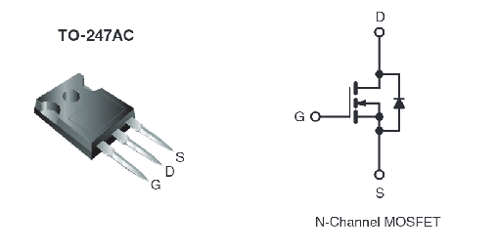

Figure : Selected MOSFET for he circuit

MOSFET ratings were determined according to simulation results and theoretical calculations. We saw at most 120V across the VDS and we measured at most 20A flow through MOSFET in the full load operation during simulation. Therefore, we decided to use this MOSFET in our circuit.

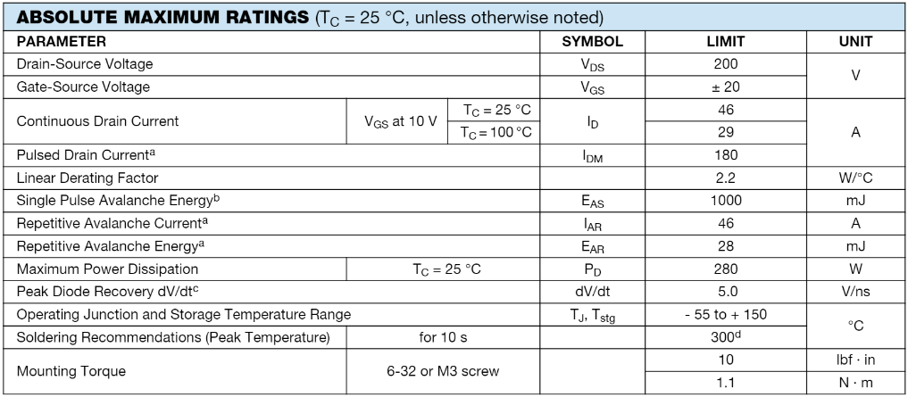

* Opto Coupler – TLP250

To isolate gate driver from the main circuit to avoid of disturbance for the pulse generator and also to avoid from possible harms of the flyback converter on the pulse generator. For this purpose, we decided to use opto coupler in our circuit. Following table illustrated the rating of the opto coupler.

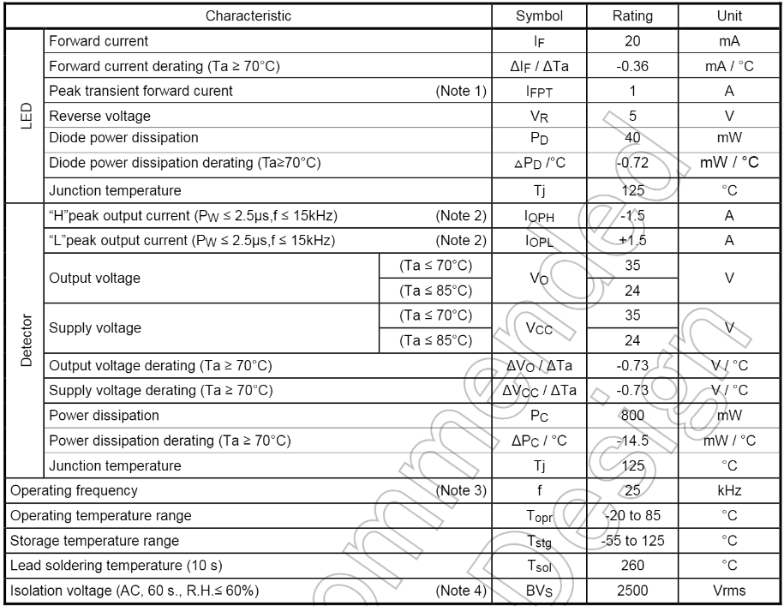

* Schottky Diode

According to measured current value in the output side of the converter, we decided current rating of the diode. Also we planned to use schottky diode to avoid from high voltage drop on diode during operation.

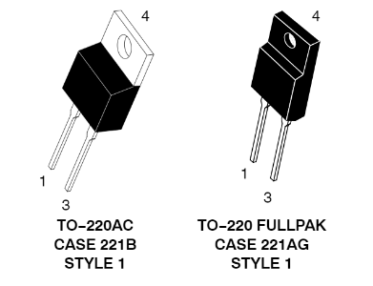

Figure : Selected Diode fort he output side of converter.

* Output Capacitor

Output capacitor selected according to maximum voltage can be obtained at the output. So that, the maximum voltage level at the output in our circuit is equal to 48 Volts. Therefore, we decided to use 100V rating capacitor at the output.

* Snubber Diode

According to simulation results, we decided rating of the snubber diode. Following table illustrates rating of the snubber diode.

